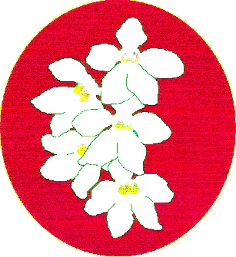
BATEMANS BAY ORCHID AND FOLIAGE SOCIETY INC.
PO Box 3334 Batehaven
NSW 2536
Newsletter March 2017 President: Ron Boyd 44721934
Temporary Editor: Ron Boyd
Vice President: Dorothy Kauffman 44740884
Secretary: Margaret Turner 0409442704
Treasurer: Anne-Marie Collins 0427885186
Committee: Rose Boyd, Lin Barnes, Maureen Anderson, Paula Brown, Brian Perkins.
…………………………………………….
President report
Hi members welcome to March 2017 Club Newsletter. Margaret Turner is away for a month so I am doing this month’s edition.
Dr. Jane Wright gave a wonderful talk at the February club meeting on how she grows her Masdevalias, as well as a very good presentation on what judges look for when judging Masdevalias and associated families.
At our March 6th 2017 meeting, Jeanne Dunn will give a talk on how she grows her Dockrillias. Jeanne hopefully will have Dockrillias flasks for sale as well as plants.
February was a busy meeting, passing and approving many motions. The Bus trip to Orchids Out West (near Richmond NSW) 2017 on Friday 26th May was approved by members and now free to all Batemans Bay Orchid & Foliage Soc. Inc. members. Other clubs’ members will be charged a good price of $25. If you are going and member of our club can you please email or phone me ASAP on 44721934 or email oldwents@gmail.com for your bookings. The cut of date is 14th April for our members and then other clubs’ members can book.
We have updated our Native Show Schedule to represent modern views on some aspects in the schedule, as requested by some of the senior Judges at last year’s Native Show. At our February club meeting it was checked out by a subcommittee of members and fixed and approved. Main feature you all should be happy with that there is now 2 Grand-Champions at the show; a new Grand-Champion for all other genera, for the members who do not grow and show Sarcochilus.
We are preparing a new Growing Experience plant this year. This one will be a surprise and a gift to members, one plant per membership. They will be available at the March 6th Club meeting, and this plant will be totally free courtesy of the funds raised from Bunning BBQs.
The other new Growing Experience plant, totally free to all members, one plant per membership at the moment, is Dendrobium Jonathon's Glory 'Dark Joy'. It is a fine shaped large purple kingianum type, a very good grower and top show orchid. This plant will also be totally free courtesy funds raised from Bunning BBQs.
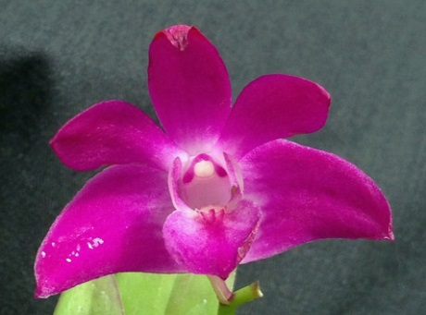
Please come along to the March meeting to pick up your free plant!

Bunning BBQ group of workers: We would like more of our Club members volunteer to help this dedicated group of workers. You will get free training, free smoko, lunch and afternoon tea & free drinks as well as feeling great for helping us out. We basically have 2 shifts; Morning shift from 8am to 12 noon and afternoon shift from 12 noon to around 4pm finish. On busy days like Saturdays we usually have a shift from 11am to around 1pm to cover the very busy lunchtime. Only safety requirements are fully enclosed footwear.
Good Growing and see you all at the Club meeting on Monday March 6th
Ron Boyd

For those who love Sarcochilus, and master breeder and grower, Mr Neville Roper, here is a wonderful tribute to him.
Essay Competition 2016; 2nd Prize Winner.
Master, Teacher, Hybridiser
By Daniel Coulton
<http://australianorchidfoundation.org.au/wp-content/uploads/2017/02/2nd-Prize-Daniel-Coulton-Copy.pdf>
Our clubs supper / coffee break is a chance to socialise, many thanks to all those who bring in nibbles for all to enjoy.

Attendance Book: It is most important that people attending the monthly meetings sign the attendance book. This is required for insurance purposes. If you don’t sign you are not covered and cannot claim in the event of an accident.
Our next meeting: Will be Monday March 6th 6.30pm plants on benches for voting on at 7pm. Meetings start 7.30pm
This month’s guest speaker will be Jeanne Dunn from down in Victoria who has driven all the way up to talk on how she grows her favourite orchid, Dockrillias. There will possibly be some Dockrillia in flasks and plenty of Dockrillia plants for sale.
There are still some members who need to collect plants that they were awarded for benching during 2016. Those members are Brian Coulton, Peter & Laurine Vanest, Could these members let either Margaret or Anne-Marie know which meeting they will be attending so that we can have their plants available for them. Thanks
…………………………
Welfare Officer
Maureen Anderson has kindly taken on the role of Welfare Officer; you can contact Maureen on Ph. 44717908 between the hours of 8am to 9am and any time after 6pm. If you know of any member who is not well or in hospital could you kindly pass on the information to Maureen?

February Meeting
Open Section
Species: 1st Liz Cleaver & Tony Groube 2nd Leanda O’Connor; 3rd Rob & Sue Fish
Australian Native Orchid: Liz Cleaver & Tony Groube
Laeliinae over 70mm: Sylvia Hawkins
Vandaceous: 1st Rob & Sue Fish 2nd Rob & Sue Fish 3rd Liz Cleaver & Tony Groube
Paphiopedilum: Ron & Rose Boyd
Oncidiinae Alliance: Liz Cleaver & Tony Groube
Seedling: Rob & Sue Fish
Miscellaneous: Rob & Sue Fish
Foliage: 1st Leanda O’Connor; 2nd Liz Cleaver & Tony Groube
Fern: Leanda O’Connor
Plant of the Night
3 way tie
Paphiopedilum In Charm Laser Light x Hsinying Web ‘In Lim’ – Rob & Sue Fish
Paph St Swithin - Ron & Rose Boyd
Ryncholaelia Pink Delight ‘Burdiken’ - Sylvia Hawkins
Novice Section
Oncidiinae Alliance: 1st Megan & Jim 2nd Lin
Seedling: 1st Megan & Jim [1]
Foliage: Dorothy
Plant of the Night
[1] Angraecum - Megan & Jim Quinlivan

Plant of the night February 6th 2017 meeting Open Section there were 3 winners Sylvia Hawkins with
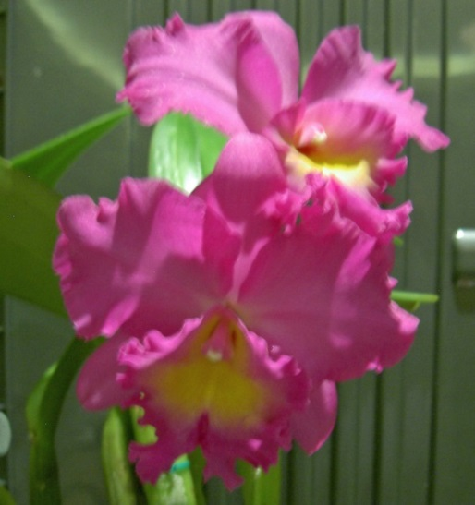
Ryncholaelia Pink Delight ‘Burdiken’

Ron & Rose Boyd with Paphiopedilum St. Swithin.
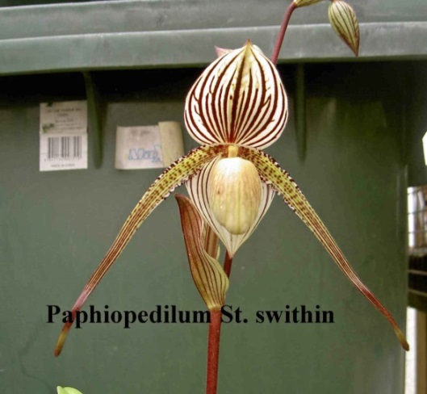

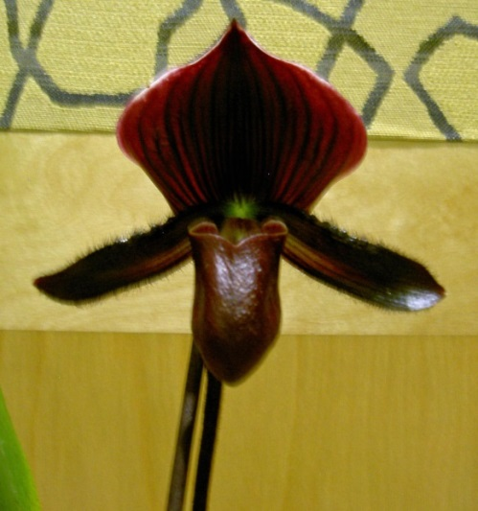
Rob & Sue Fish with Paphiopedilum In Charm laser Light x Hsinying Web ‘In Lim’
Novice Section
Angraecum - Megan & Jim Quinlivan
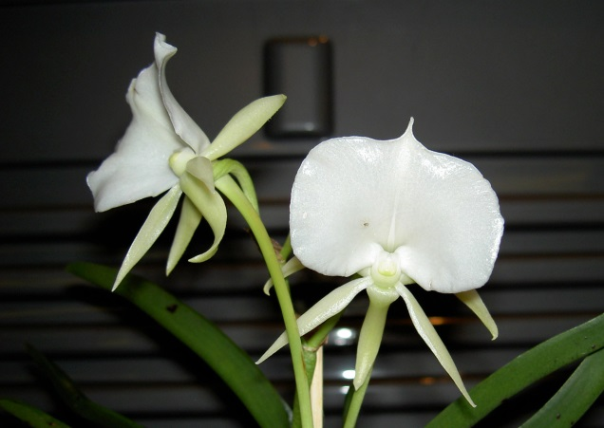
February General Meeting opened at 7:30p.m. On Monday, 6th February, at Batemans Bay Soldiers Club
President Ron opened the meeting at 7:30pm, thanking all for coming and introducing our guest speaker.
Our guest speaker Dr. Jane Wright gave her talk on Masdevalias. She was presented by the President with a gift and a cheque for travelling expenses. Jane had plants for sale prior to meeting and at the supper break.
MINUTES:
December minutes be accepted and matters arising be dealt with in general business.
MOVED to be accepted L. O’Connor SECONDED A.M. Collins passed
Growing experience – Tony suggested that the growing experience be free – re discuss in General Business.
Break for supper [ 20min].
PRESENT:
Members 24 Apologies 2 Visitors 3
Dot asked permission to tape the meeting. It has to be announced every month. Vote on tape recorder for tonight – 2 against.
Correspondence Out
-letter re when judges needed
-letter to Soldiers Club for 2018 dates for meetings and shows
-thank you letters – Soldiers Club, Batehaven Hardware & Garden Supplies, Belinda for auditing financial statements, Jim & Min Purtell for book donation, Yvonne Breton membership, Krystal at Bunnings.
-BBOFS Newsletters
Correspondence In
-Magazines – Orchids Australia
-Newsletters- Wagga Wagga, Sapphire Coast, Milton/Ulladulla, Canberra, N.S.W. , Shoalhaven, EOC.
-booking request for judges
MOVED to be accepted – A.M. Collins SECONDED S. Hawkins PASSED
TREASURER’S REPORT
Presented December and January reports
December – balance as at 31st December $17,483.78 . Expenditure $1,201.92 and Income $2,442.91 . Balance adjusted for one outstanding cheque of $30.
Balance as at 31st January $17,266.10 . Expenditure $1,077.43 and Income $854.75 . Balance adjusted for one outstanding cheque of $25.
MOVED to be accepted A.M. Collins SECONDED T. Groube PASSED
A request was made by Tony Groube that Grumpy’s Shed “stock on hand “ value be included in the Treasurer’s report. This was discussed and will be added when possible.
Requested payment of outstanding cheques.
MOVED to be accepted A.M. Collins SECONDED R. Fish PASSED

GENERAL BUSINESS
1] Next General Meeting Monday, March 6th 2017
2] Dr Jane Wright spoke about the Canberra Work Shop, 18th & 19th March. Entry forms were on the table available for members.
3] Bus trip to Orchids Out West 26th May, 2017. Batemans Bay will sub Moruya/Milton at $25 per head. Discussion followed.
Tony put a motion
“Batemans Bay Orchid & Foliage Society with free transport for all B.B.O.F.S. members and the 2 other clubs & public will be charged $25.”
Seconded by Robert Fish. Passed with 2 against.
Anne-Marie to check with Department of Fair Trading that this is possible.
4] 2017 Show Marshall – Ron Boyd
Assistant Show Marshalls – Lin and Margaret to be helped by Tony & Liz
5] Ron needs volunteers for Bunnings B.B.Q. 3rd March
6] Voice Digital Recorder $149.00 - look into legalities of its use at our meetings.
7] Revised 2017 Native Show schedule – to be discussed after the meeting – those interested to attend.
8] Growing Experience- Tony moved
“The growing plants will be free of charge per membership number and have to come to meetings to be picked up.”
Seconded by Robert Fish passed
9] Write up in Orchid magazine discussed. None for 2016 Native show.
10] Robert Fish inquired if the club had an assets registry? Yes - as it was required for the Dept. of Fair Trading form sent last December.
11] Albury Conference – no theme as yet – needs to be discussed next meeting.
12] Plant of the Night certificates from 2016 handed out.
Batehaven – [17] Magda Smyth
Raffle – Liz, Rose, Dot X2, Lin X2, Sylvia, Sue, Leanda, Allan, Paula
Thank you to Leanda O’Connor for taking February’s minutes.
Meeting closed 9:35 p.m.
A.M. Collins Acting Secretary.
Next General Meeting Monday, 6th March.
Memberships were due on the 1st January and can be paid at the February meeting. It remains at $15 for single member and $20 per couple.

Brian Coulton is thinning his collection & has some orchids for Sale.
For sale will be: Large Cymbidiums which should flower this season - $20, (many have won awards and are of show quality), smaller seedlings due to flower the season following - $15 (there are some beautiful, awarded orchids amongst these),
Cattleya’s - various prices most will flower this season with some absolute stunners growing strongly. Various accessories such as orchid stands (concrete and PVC), slatted baskets and varnished wooden display stands all at cheap prices.
To purchase any of these orchids just ring me on 4472 2483 to make sure that I am at home and drop around to 23 Yarrabee Dve Catalina.
Brian Coulton

ANNUAL ORCHID WORKSHOP IN CANBERRA
The Orchid Society of Canberra will be hosting the annual Orchid Workshop in Canberra over the weekend of 18-19 March 2017. Bill Miles of Orchid Species Plus and Stephen Stebbings of Orchids on Newbold will be our guest presenters and will have many beautiful orchids for sale. They will give a number of talks on species and hybrids in their areas of expertise. There will be something for everyone – from the beginner to the experienced grower. We hope also to have a couple of talks by local Canberra orchid specialists. The format will be similar to previous workshops, with morning and afternoon presentations on Saturday, starting about 9am, and a morning session on Sunday. Tea and coffee (with cake and biscuits), available during the breaks between sessions, will be covered by the registration fee of $25. Lunch and dinner will be at the expense of participants. The brochure and registration form are available on http://www.orchidsocietynsw.com.au/ Documents/Canberra17Workshop.pdf

Dates for your Diaries for 2017
February 6 - First club night for 2017
March 18 – 19 March workshop Canberra
May 26 – 28 Orchids Out West
July 7 – 8 EOC Winter show Moruya
July 14 – 16 MUOS Winter Show
July 20 – 22 BBOFS Winter Show
August 25-27 Melbourne Orchid Spectacular
September 1 – 2 EOC Spring show Narooma
September 7 – 9 BBOFS Spring Show
September 15 – 17 MUOS Spring Show
October long weekend S&W Regional Show & Conference Wodonga
October 19 – 21 BBOFS Native Show.

Major Sponsors of our Club
Batemans Bay Soldiers Club
Beach Road, Batemans Bay

Bunnings of Batemans Bay
Sponsoring our Club through its BBQs

…..….Batehave Hardware & Garden Centre
………………………………….…….
Kate Willis
Postage of the newsletters

The cultural information offered in this newsletter is intended as a guide only. Batemans Bay Orchid & Foliage Soc. Inc. cannot be held responsible for any loss or damage that may occur to plants as a result of using this information.

